**Linear pulse propagator with dispersive and non-linear media**

Dheeraj Golla

A linear pulse propagator was developed in a previous note. Beam propagation method was used to propagate femtosecond Gaussian pulses in time and space. The Discreet Hankel Transform (DHT) was used to break the transverse (x,y)spatial profile down to its components in order to propagate each component along the z-axis and Fast Fourier Transform (FFT) was used to propagate the various frequency components in time. This project deals with propagation in dispersive media and non-linear media

1. Background

The expression for the electric field at (x,y,z) at time t, is expressed as:



This expression helps us compute the electric field at (x,y,z,t) if the field at (x,y,0,0) is known. Putting it another way, the light pulse is propagated by a distance ‘z’ in time ‘t’ (where vg= z/t is the group velocity). The reference frame can move with the group velocity to keep the pulse centered on t=0.

The inner most integral in the above expression is the Hankel transform of the field. The Hankel transform is equivalent to a 2d Fourier Transform for cylindrically symmetric pulses. This Transform is multiplied by the propagator – this is the propagation step.



Finally, an inverse Hankel Transform (which is the same as a Hankel Transform since a HT is it’s own inverse) brings the pulse back to the real space. This process is repeated for all frequencies in the initial pulse. The initial pulse is broken into it’s frequency components using a usual Fourier Transform.

It’s to be noted that the DHT algorithm has many advantages over 2d FFT. The first is speed since the DHT is faster than 2D FFT for similar resolution. It is also possible that the square grid of an FFT algorithm will imprint anisotropies on the cylindrically symmetric pulses. This is the second advantage.

2. The code and results for BPM in air

The MATLAB code below uses the BPM discussed above to propagate a 35fs pulse with a Gaussian profile of FWHM of 100 microns over a Rayleigh range length. The center wavelength is 800nm.

%Beam propagation method - DHT for spatial profile propagation and FFT for

%temporal

close all;

%%%%%%%%tempoaral profile construction%%%%%%%%%%

tmax = 300; %total width of time domain in fs

c = 3*10^8 ; %speed of flight in m/s

N = 2048; %time resolution

dt=tmax/(N-1);

t = (-tmax/2:dt:tmax/2);

lambda0 = 785 * 10^(-9); %carrier wavelength in meters

w0 = 2*pi*(c/lambda0) * (10^-15);% carrier frequency in fs^-1

%phit = zeros(1,length(t)); %phase as a function of time

%phit = -(0.09)*(t.^1); %linear phase equals shift

phit = (0.01)*(t.^2); %experiment with the chirp (0.04 default)

sigsq = (3.5*10).^2; %sigma squared = width of the envelope squared in fs^2

I = exp((-t.^2)/(2*sigsq)); %intensity envelope

ewt = exp(1i*(w0*t - phit));

E.time = (1).*sqrt(I).*((ewt)); %electric field in time domain

E.w = fftshift(fft(ifftshift(E.time))); %electric field in frequency domain through FFT

dw = 2*pi/tmax;

wmax = 2*pi/dt;

w = -wmax/2:dw:wmax/2; % frequency array in fs^-1 units

n=1.0*ones(1,length(w)); % refractive index

x = ((2*pi*c)./(w*10^15)).*(10^6); %Wavelength in microns

%n=sqrt(1+1.03961212./(1-0.00600069867./(x.^2))+0.231792344./(1-0.0200179144./(x.^2))+1.01046945./(1-103.560653./(x.^2)));

I_w = (abs(E.w)).^2; %intensity of electric field in frequency domain

A = (I_w/max(I_w))>0.0001; %phase blanking to avoid random phase values

I_w = A.*I_w;

phiw = A.*unwrap(angle(E.w)); %phase blanking to avoid random phase values

figure; plot(t,I);title('temporal profile before propagation')

%%%%%%%%spatial domain construction (transverse coordinates)%%%%%%%%%%

sigma = 100.0e-06; %spot size at z=0 in meters

z = pi.*(sigma.^2)/lambda0; %propagation length in meters (equal to Rayleigh range in this example)

steps = 10;

dz = z/steps;

Rmax = 5.0e-04; %maximum spatial grid location in transverse plane in meters

M = 200; %spatial resolution

T = (n.*z/c)*10^15; %group delay in fs

H = dgDHT(Rmax,M); % the H struct contains the DHT matrix and r grid and k grid

r=H.rgrid; %spatial cordinates

k=H.kgrid; %transverse cordinates

E.space = exp((-r.^2)./sigma.^2); %Electric field as a function of transverse coordinates

figure;

plot(r,abs(E.space).^2);

title('spatial profile before propagation')

z_w = zeros(M,N);

b = zeros(1,N);prop = zeros(M,N);Kz = zeros(M,N);hank_wave = zeros(M,N);step = zeros(M,N);

E_0 = (E.space)*E.time; % initial Electric field - 2d matrix - transverse coordinate and time

E.z_w = E.space*E.w; % initial Electric field - 2d matrix - transverse coordinate and frequency

for pp = 1:steps

b = zeros(1,N);prop = zeros(M,N);Kz = zeros(M,N);hank_wave = zeros(M,N);

for m=1:N

if (abs(w(m))<5 && abs(w(m))>0.5) %only propagate these frequencies - optional

b(m) = ((n(m) .* (w(m)))/c)*10^15;

Kz(:,m) = sqrt(b(m).^2 - k.^2); % k is not a function of m

prop(:,m) = exp(1i*(Kz(:,m) - b(m))*dz); % linear propagator

hank_wave(:,m) = H.DHT*E.z_w(:,m); % DHT operation

E.z_w(:,m) = H.DHT * (prop(:,m).*hank_wave(:,m)); %inverse DHT operarion after propagation

end

end

end

E_t_z = ifftshift(ifft(fftshift(E.z_w),N,2));

figure;

plot(r,abs(E_t_z(:,1)).^2);title('spatial profile after propagation')

figure;

plot(t,abs(E_t_z(1,:)).^2);title('temporal profile after propagation')

figure;

imagesc(abs(E_t_z).^2);title('after propagation')

figure;

imagesc(abs(E_0).^2);title('before propagation')

Key to Figures

Time is in Femtoseconds. Spatial dimension (radial coordinate) is in meters.

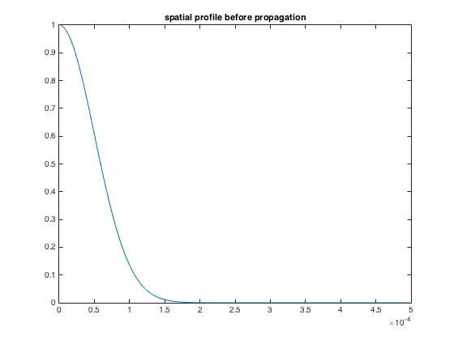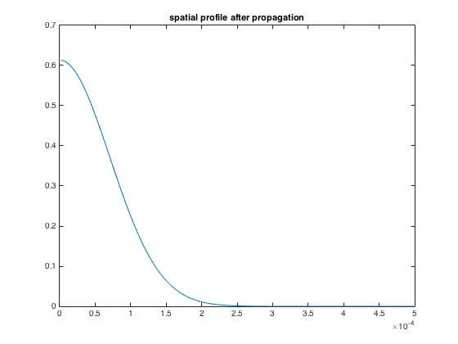

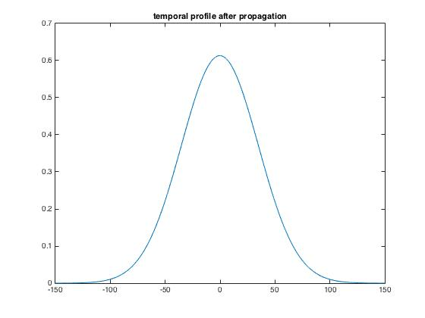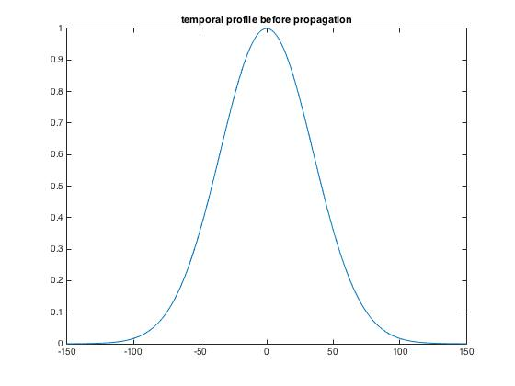

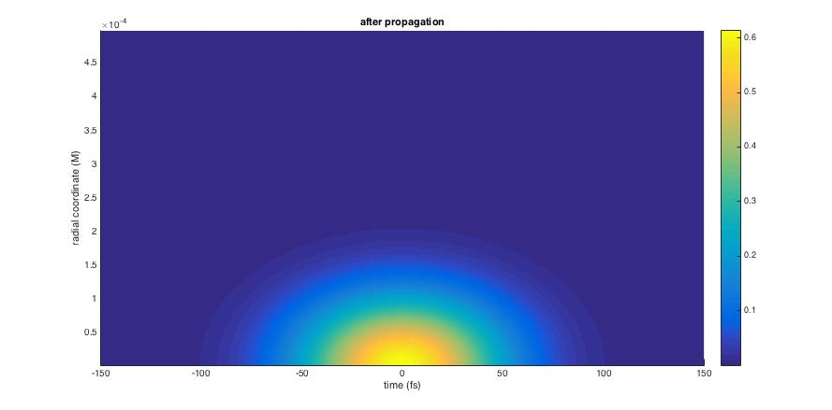

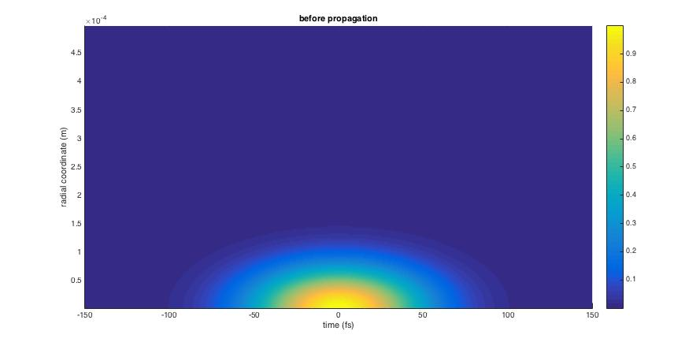

Observations:

The beam defocusses spatially after propagating over a Rayleigh range along the z-axis **in air**. The temporal shape and width remain the same. The above figure shows max intensity for the temporal shape as 0.7 since the profile is plotted at a cut.

Introducing Chromatic dispersion into the code

The Sellemier equation for glass is given by

n=sqrt(1+1.03961212./(1-0.00600069867./(x.^2))+0.231792344./(1-0.0200179144./(x.^2))+1.01046945./(1-103.560653./(x.^2)))

This expression is introduced into the code instead of n=1. The interesting result is that with chromatic dispersion, the pulse is not as defocussed as it would be in air.

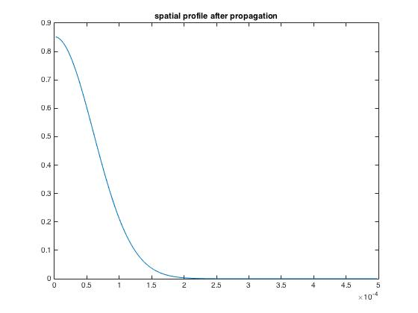

Compare the above figure with Figure 1, we see that spatially, the beam is not defocussed as much.

**Introducing Kerr nonlinearity in the BPM code**

I introduced Kerr nonlinearity in the MATLAB BPM code we discussed above by indroducing a small intensity dependent refractive index term and using the so called **Lens Method**. The Lens operator is defined by

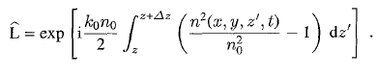



This operator introduces a non-linear phase shift in every step of the BPM.

The steps I took are:

1. Broke the z-propagation into tiny dz steps.

2. Use the DHT-FFT method to propagate the beam by dz: E(r,z) 🡪 E(r,z+dz)

3. Operate the lens operator on the Electric field at z+dz: E(r,z) 🡪 L* E(r,z+d)

4. repeat.

I experimentally found the value of the nonlinear coefficient (since we use arbitrary units for intensity).

The code

Most of the code is the same as before except inside the For loop as highlighted. The propagation distance is a quarter of the Rayleigh range at 800nm.

%%%% BPM in a kerr medium %%%%%%%%%%%%

%Beam propagation method - DHT for spatial profile propagation and FFT for

%temporal

close all;

%%%%%%%%tempoaral profile construction%%%%%%%%%%

tmax = 300; %total width of time domain in fs

c = 3*10^8 ; %speed of flight in m/s

N = 1024; %time resolution

dt=tmax/(N-1);

t = (-tmax/2:dt:tmax/2);

lambda0 = 785 * 10^(-9); %carrier wavelength in meters

w0 = 2*pi*(c/lambda0) * (10^-15);% carrier frequency in fs^-1

%phit = zeros(1,length(t)); %phase as a function of time

%phit = -(0.09)*(t.^1); %linear phase equals shift

phit = (0.01)*(t.^2); %experiment with the chirp (0.04 default)

sigsq = (3.5*10).^2; %sigma squared = width of the envelope squared in fs^2

I = exp((-t.^2)/(2*sigsq)); %intensity envelope

ewt = exp(1i*(w0*t - phit));

E.time = (1).*sqrt(I).*(((ewt))); %electric field in time domain

E.w = fftshift(fft(ifftshift(E.time))); %electric field in frequency domain through FFT

dw = 2*pi/tmax;

wmax = 2*pi/dt;

w = -wmax/2:dw:wmax/2; % frequency array in fs^-1 units

n=1.0*ones(1,length(w)); % refractive index

x = ((2*pi*c)./(w*10^15)).*(10^6); %Wavelength in microns

%n=sqrt(1+1.03961212./(1-0.00600069867./(x.^2))+0.231792344./(1-0.0200179144./(x.^2))+1.01046945./(1-103.560653./(x.^2)));

n2 = 0.000005;

I_w = (abs(E.w)).^2; %intensity of electric field in frequency domain

A = (I_w/max(I_w))>0.0001; %phase blanking to avoid random phase values

I_w = A.*I_w;

phiw = A.*unwrap(angle(E.w)); %phase blanking to avoid random phase values

figure; plot(t,I);title('temporal profile before propagation')

figure; plot(w,abs(E.w).^2);title('spectrum before propagation')

%%%%%%%%spatial domain construction (transverse coordinates)%%%%%%%%%%

sigma = 100.0e-06; %spot size at z=0 in meters

z = (pi.*(sigma.^2)/lambda0)./4; %propagation length in meters (equal to half Rayleigh range in this example)

steps = 5;

dz = z/steps;

Rmax = 5.0e-04; %maximum spatial grid location in transverse plane in meters

M = 200; %spatial resolution

T = (n.*z/c)*10^15; %group delay in fs

H = dgDHT(Rmax,M); % the H struct contains the DHT matrix and r grid and k grid

r=H.rgrid; %spatial cordinates

k=H.kgrid; %transverse cordinates

E.space = exp((-r.^2)./sigma.^2); %Electric field as a function of transverse coordinates

z_w = zeros(M,N);

b = zeros(1,N);prop = zeros(M,N);Kz = zeros(M,N);hank_wave = zeros(M,N);step = zeros(M,N);

figure;

plot(r,abs(E.space).^2);

title('spatial profile before propagation')

% E_0 = (E.space)*E.time; % initial Electric field - 2d matrix - transverse coordinate and time

% E.z_w = E.space*E.w; % initial Electric field - 2d matrix - transverse coordinate and frequency

for s = 1:steps

fprintf(1,'executing %d out of %d, distance = %d\n',s,steps,s*dz);

b = zeros(1,N);prop = zeros(M,N);Kz = zeros(M,N);hank_wave = zeros(M,N);

E_0 = (E.space)*E.time; % initial Electric field - 2d matrix - transverse coordinate and time

E.w = fftshift(fft(ifftshift(E.time))); %electric field in frequency domain through FFT

E.z_w = E.space*E.w; % initial Electric field - 2d matrix - transverse coordinate and frequency

for m=1:N

%if (abs(w(m))<5 && abs(w(m))>0.5) %only propagate these frequencies - optional

b(m) = ((n(m) .* (w(m)))/c)*10^15;

Kz(:,m) = sqrt(b(m).^2 - k.^2); % k is not a function of m

prop(:,m) = exp(1i*(Kz(:,m) - b(m))*dz); % linear propagator

hank_wave(:,m) = H.DHT*E.z_w(:,m); % DHT operation

E.z_w(:,m) = H.DHT * (prop(:,m).*hank_wave(:,m)); %inverse DHT operarion after propagation

dn = n2*(abs(E.z_w(:,m)).^2);

L = exp(-1i*b(m)*(dn.^2)*dz./(n(m))); %Lens operator

E.z_w(:,m) = L.* E.z_w(:,m);

%end

E_t_z = ifftshift(ifft(fftshift(E.z_w),N,2));

end

end

E_w_z = fftshift(fft(ifftshift(E.z_w),N,2));

figure; plot(w,abs(E_w_z(1,:)).^2);title('spectrum after propagation')

figure;

plot(r,abs(E_t_z(:,512)).^2);title('spatial profile after propagation')

figure;

plot(t,abs(E_t_z(1,:)).^2);title('temporal profile after propagation')

figure;

imagesc(abs(E_t_z).^2);title('after propagation')

figure;

imagesc(abs(E_0).^2);title('before propagation')

Results

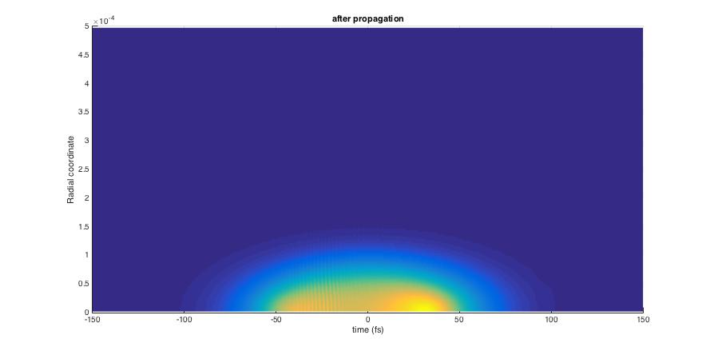

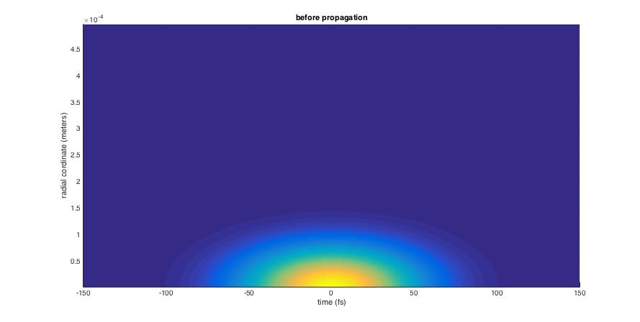

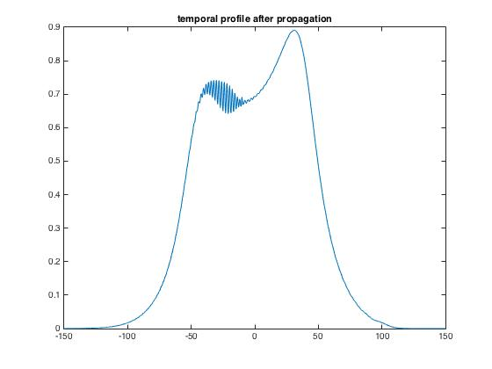

The spatial and temporal shape of the pulse is fairly distorted due to the introduction of non-linearity.